**A PROJECT REPORT**

**Foodie System**

|  |  |
| --- | --- |
| ***Submitted by:*** |  |
| **Md. Omar Faruk** | **ID: 19202103393** |
| **Afia Jahin** | **ID: 20211103052** |
| **Kazi Rifat Hossain Ratun** | **ID: 20211103060** |
| **Ruhul Amin Rajib** | **ID: 20211103064** |
| **Sefat Binte Saied Medha** | **ID: 19202103372** |

***A Project Submitted in Partial Fulfillment of the Requirements for the Degree of Bachelor of Science in Computer Science of the Bangladesh University of Business and Technology (BUBT)***



**DEPARTMENT OF COMPUTER SCIENCE & ENGINEERING**

**BANGLADESH UNIVERSITY OF BUSINESS AND TECHNOLOGY (BUBT)**

**DHAKA, BANGLADESH**

**September, 2023**

**ABSTRACT**

The Foodie System web app has been developed to allow people to give their reviews online. Using this website, people can give reviews on any restaurant's food. On this website, there will be only a user panel. People can create their accounts and log in anytime using their email or saved social media logins. Users can express their opinions as reviews and also have the option to like or dislike other users' reviews. There will also be a search option where people can find restaurants by searching for food names, restaurant names or location. Users can write detailed reviews about their dining experiences at various restaurants. They can rate different aspects of the experience, such as food quality, service, ambiance, etc. The review system encourages users to provide constructive feedback and share specific details about their visit. The app offers a powerful search option that allows users to find restaurants based on specific criteria. Users can find a list of reviews for that particular restaurant, helping them make informed decisions. Users receive notifications for various activities, such as when someone likes their review, when they receive a reply, or when a new review is posted for a restaurant they've reviewed. The web app is designed to be accessible and user-friendly on various devices, including desktops, tablets, and mobile phones.

**DECLARATION**

I hereby declare that the project entitled “Foodie System” submitted for the degree of Bachelor of Science Engineering in Computer Science and Engineering in the faculty of Computer Science and Engineering of Bangladesh University of Business and Technology (BUBT), is our original work and that it contains no material which has been accepted for the award to the candidates of any other degree or diploma, except where due reference is made in the next of the project to the best of our knowledge, it contains no materials previously published or written by any other person except where due reference is made in this project.

|  |  |  |  |  |  |
| --- | --- | --- | --- | --- | --- |
| Md. Omar Faruk |  |  | Afia Jahin |  | Ruhul Ami Rajib |
| ID: 19202103393 |  |  | ID: 20211103052 |  | ID:20211103064 |
| Intake: 44 |  |  | Intake: 46 |  | Intake: 46 |
| Section: 04 |  |  | Section: 02 |  | Section: 02 |
|  |  |  |  |  |  |

`

|  |  |  |
| --- | --- | --- |
| Kazi Rifat Hossain Ratun |  | Sefat Binte Saied Medha |
| ID: 20211103060 |  | ID: 19202103372 |
| Intake: 46 |  | Intake: 44 |
| Section: 02 |  | Section: 04 |

**CERTIFICATION**

This project “Foodie System” report submitted by Md. Omar Faruk, Sefat Binte Saied Medha, Afia Jahin, Kazi Rifat Hossain Ratun and Ruhul Amin Rajib students of Department of Computer Science and Engineering, Bangladesh University of Business and Technology(BUBT), under the supervision of Atiya Masuda Siddika, Lecturer, Department of Computer Science and Engineering has been accepted as satisfactory for the partial requirements for the degree of Bachelor of Science Engineering in Computer Science and Engineering.

**Atiya Masuda Siddika Md. Saifur Rahman**

**Lecturer Assistant Professor**

**& Project Supervisor & Chairman**

**Department of CSE Department of CSE**

**DEDICATION**

**Dedicated to all our parents who work hard to make our journey peaceful.**

**ACKNOWLEDGEMENTS**

I would like to thank the following people for their help in the production of this project:

Atiya Masuda Siddika, project supervisor for all of his ongoing assistance with the project, without whose help and support throughout, this project would not have been possible.

Md. Mridul Saha and Susmoy Bless Singh for testing the web application developed in the project and providing feedback.

**APPROVAL**

This Thesis “Foodie System” Submitted by Md. Omar Faruk, Afia Jahin, Kazi Rifat Hossain Ratun, Ruhul Amin Rajib and Sefat Binte Saied Medha Department of Computer Science and Engineering (CSE), Bangladesh University of Business and Technology (BUBT) under the supervision of Atiya Masuda Siddika, Lecturer and Department of Computer Science and Engineering has been accepted as satisfactory for the partial fulfillment of the requirement for the degree of Bachelor of Science (B.Sc. Eng.) in Computer Science and Engineering and approved as to its style and contents. --------------------------------

Supervisor:

Atiya Masuda Siddika

Lecturer

Department of Computer Science and Engineering (CSE)

Bangladesh University of Business and Technology (BUBT)

Mirpur 2, Dhaka 1216, Bangladesh

--------------------------------

Chairman: Md. Saifur Rahman

Assistant Professor and Chairman

Department of Computer Science and Engineering (CSE)

© Copyright by Md. Omar Faruk, Afia Jahin, Kazi Rifat Hossain Ratun and Ruhul Amin Rajib, Sefat Binte Saied Medha All Right Reserved

**ABBREVIATIONS AND NOMENCLATURES**

|  |  |
| --- | --- |
| **AJAX** | **Asynchronous JavaScript And Xml** |
| **API** | **Application Programming Interface** |
| **CS** | **Client/Server** |
| **CSS** | **Cascading Style Sheet** |
| **DBMS** | **Database Management System** |
| **XML**  **HTML**  **PHP** | **Extensible Markup Language**  **Hypertext Markup Language**  **Hypertext Preprocessor** |
|  |  |

**Table of Contents**

Abstract i.

Declaration ii.

Certification iii.

Dedication v.

Acknowledgement v.

Approval vi.

Copyright vi.

Abbreviations vii.

Chapter 1: **INTRODUCTION**  1-3

1.1 Introduction 1

1.2 Motivation 2

1.3 Perspective 2

1.4 Objective of the Project 2

1.5 Contribution 2

1.6 Conclusion 3

Chapter 2: **PROPOSED MODEL** ………………………………….. 8-15

2.1 Introduction …………………………… 8

2.2 Feasibility Analysis …………………… 8

2.2.1 Technical Feasibility …………. 8

2.2.2 Operational Feasibility ……….. 8

2.3 Requirement Analysis ………………… 8

2.3.1 Non-Functional Requirements …….. 8

2.3.2 Functional Requirements …….. 8

2.4 System Design ………………………… 8

2.4.1 Waterfall Method …………….. 8

2.4.2 DFD ………………………….. 8

2.4.3 ER Diagram ………………….. 8

2.4.4 Flow Chart …………………… 8

2.4.5 Use Case Diagram …………… 8

2.4.6 Class Diagram ……………….. 8

2.5 Implementation ……………. 8

2.5.1 Algorithms & pseudocode ………… 8

2.5.2 Front End ………………. 8

2.5.2.1 Forms Design …………. 8

2.5.3 Back end ……………… 8

2.6 Conclusion ……………………

Chapter 3: **EXPERIMENTAL RESULT …………………………** 9

3.1 Introduction ……………………… 9

3.2 Result Analysis ……………… 9

3.3 Conclusion …………………..

Chapter 4: **USER MANUAL …………………………** 21

4.1 Introduction ……………………… 21

4.2 System Requirements ……………… 21-22

4.2.1 Software Requirement ………………….. 22

4.3 User Interface ……………… 23-27

4.3.1 Sign-up/Login ……………… 23

4.3.2 Home page……………… 24

4.3.3 Review page ……………… 26

4.3.4 Foodie…………… 27

4.3.5 Account information………………….

Chapter 5: **CONCLUSION & FUTURE WORKS ………………… 9**

5.1 Conclusion ……………………. 9

5.2 Future Works …………….

# CHAPTER 1

# INTRODUCTION

**1.1 Introduction**

The Foodie System web app has been developed to allow people to give their reviews online. Using this website, people can give reviews on any restaurant's food. On this website, there will be only a user panel. People can create their accounts and log in anytime using their email or saved social media logins. Users can express their opinions as reviews and also have the option to like or dislike other users' reviews. There will also be a search option where people can find restaurants by searching for food names.

**1.2 Motivation**

The biggest motivation to serve this project is to help people find good food without any hassle and also without wasting time and money. People can give their honest review on this website because it does not promote any food company or restaurant. This website will highlight the best quality food from various eateries. This is basically for foodies who love to eat quality full foods on any restaurant or the best food in any restaurant, so they can check the reviews and can get their location and can taste good food. We, as a team are working on this project to help the people finding the best and healthy food. Hopefully we will do the project in a very short time.

We rely that, ”**Let food be thy medicine and medicine be thy food.”**

**1.3 Perspective**

The Foodie System will be created in two sectors. One will be visible that people can visit by the website and other will be the administrator part. The two users (The admin & Visitor) can interact by the system. The Foodie System is a comprehensive food rating and review app designed to provide users with a platform to discover, evaluate, and engage with individual restaurants. This app allows users to access restaurant reviews, provide feedback, and interact with other food enthusiasts. It is a user-centric platform aimed at enhancing the dining experience and promoting restaurants based on customer preferences.

* 1. **Objectives of the Project**

* Food reviewers can write reviews of any restaurants and on their food items and foodies can view the reviews and like or dislike them.
* User can give rate to the restaurants on a scale (1 to 5 stars) and write detailed in the reviews.
* Establish and enforce community guidelines to maintain the integrity of ratings and reviews, preventing fake reviews and spam.
* By this System, the user will provide accurate and authentic reviews and ratings. There's an assumption that users won't engage in fraudulent activities like creating fake accounts to manipulate ratings.
* The System relies on user authentication systems to ensure that reviews are attributed to genuine users. This involves secure login processes and possibly integration with social media or email services.
* Foodies can easily find the details such as name, cuisine type and average rating.
* Encourage users to upload photos of their meals and dining experiences to enhance to get good reviews for foodies.
* The website assumes that users will enable location services to provide location-based recommendations and ensure that reviews are relevant to their area.

**1.5 Contribution**

Md. Omar Faruk - Providing solution, java & JavaScript

Kazi Rifat Hossain Ratun - Data Analyst, PHP

Afia Jahin - HTML, CSS

Sefat Binte Saied Medha - Database , HTML

Ruhul Amin Rajib - JavaScript

**1.6 Conclusions**

In conclusion, this project aims to serve the people to get healthy and good food. In the following sections, we will provide an overview of the system and present our findings and recommendations. We believe that this project will contribute to solve their problems and help them to get authentic reviews so they can taste best foods. We invite you to visit the website and give more and more honest review and also give rate on reviews.

**CHAPTER 2**

**PROPOSED MODEL**

**2.1 Introduction**

The Foodie System web app has been designed to enable individuals to share their reviews online. Through this platform, users can provide feedback on the food served at various restaurants. The website exclusively features a user panel, allowing individuals to create accounts and log in using either their email addresses or saved social media credentials at their convenience. Users have the freedom to express their opinions through reviews and also possess the ability to indicate whether they like or dislike other users' assessments. Additionally, a search functionality will be available, enabling users to discover restaurants by searching for specific food items. More facilities will be included in this system that we are working on.

**2.2 Feasibility Analysis**

**2.2.1 Technical Feasibility**

The technical expertise required to develop "The Foodie System" web app is readily available. There are various app development platforms and frameworks iOS, Android, cross-platform development tools that can be utilized. The required technologies, such as GPS integration, database management, and user interface design, are well-established. The web app would require a robust database system to handle user accounts, restaurant information, reviews, and location data. This can be achieved using common database management system. The web app must be designed to handle a potentially large user base and an extensive database of restaurants. Scalability can be addressed through cloud-based solutions and proper architecture design. Given that the app will handle user accounts and potentially sensitive data, security measures such as encryption, secure authentication, and regular security audits will be crucial.

* Infrastructure
* Compatibility
* Data integration
* Security & Scalability
* Implementation

Considering the facts, we are Technically feasible.

**2.2.2 Operational Feasibility**

Ensure that the necessary human resources (developers, designers, marketing personnel, etc. and technological infrastructure are available or can be acquired within a reasonable timeframe. Define a realistic timeline for development, testing, and launch of the app, taking into account potential delays and challenges. Plan for ongoing maintenance, bug fixes, and updates to keep the app relevant and functional.

**2.3 Requirement Analysis**

**2.3.1 Non-Functional Requirements**

Non-functional requirements are attributes that describe how a system should behave, rather than what it should do.

* **Performance:** The system should be able to handle a large volume of data and transactions quickly and efficiently.
* **Scalability:** The system should be scalable to accommodate future growth and increased demand.
* **Reliability:** The system should be reliable, with a high degree of uptime and minimal downtime.
* **Security:** The system should be secure, with measures in place to protect sensitive data and prevent unauthorized access.
* **Usability:** The system should be user-friendly and intuitive, with a clear and consistent interface.
* **Accessibility:** The system should be accessible to all users, including those with disabilities, through the use of assistive technologies.
* **Compatibility:** The system should be compatible with a wide range of devices, browsers, and operating systems.
* **Maintainability:** The system should be easy to maintain and update, with clear documentation and well-organized code.
* **Interoperability:** The system should be able to communicate and exchange data with other systems used in the foodie system.
* **Compliance:** The system should comply with relevant regulations and standards, such as data protection laws and sustainability standards.

**2.3.2. Functional Requirements**

Functional requirements define the specific features and functionalities that a web app like "The Foodie System" must have to meet its intended purpose. Here are some functional requirements for "The Foodie System":

* **User Registration and Authentication**: Users should be able to create accounts with unique usernames and passwords. Users should be able to log in using their credentials. Password reset functionality should be available.
* **User Profiles:** Users should have a profile page where they can edit their personal information, such as name, profile picture, and contact details.
* **Restaurant Listings:** The app should display a list of restaurants along with their names, cuisines, and average ratings. Each restaurant should have a detail page with additional information.
* **Search and Filters:** Users should be able to search for restaurants by name, cuisine type, location, or rating. Filters should be available to narrow down the restaurant options by price range, dietary preferences.
* **Reviews and Ratings:** Users should be able to leave reviews and ratings for restaurants. Users should be able to like or dislike reviews left by other users. The average rating for each restaurant should be dynamically updated based on user reviews.
* **Location Services:** Users should be able to view the location of each restaurant on a map. The app should provide directions to the selected restaurant using a mapping service for example Google Maps.
* **User Interactions:** Users should be able to follow other users and receive updates on their activities (e.g., reviews, likes). Users should be able to receive notifications for new reviews, likes, or comments on their own reviews.
* **User Activity Feed:** Users should have a feed showing recent activities from people they follow such as new reviews, liked reviews.
* **Admin Dashboard:** Administrators should have access to a dashboard for managing user accounts, restaurants, and reported content.
* **Social Media Integration:** Users should be able to share restaurant details or reviews on social media platforms.
* **Feedback and Support:** Users should have a way to contact support for technical issues or general inquiries.

**2.4 System Design**

**2.4.1 Waterfall Method**

The Waterfall methodology — also known as the Waterfall model — is a sequential development process that flows like a waterfall through all phases of a project (analysis, design, development, and testing, for example), with each phase completely wrapping up before the next phase begins.

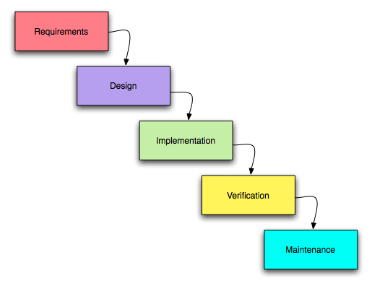

**2.4.2 Data Flow Diagram:**

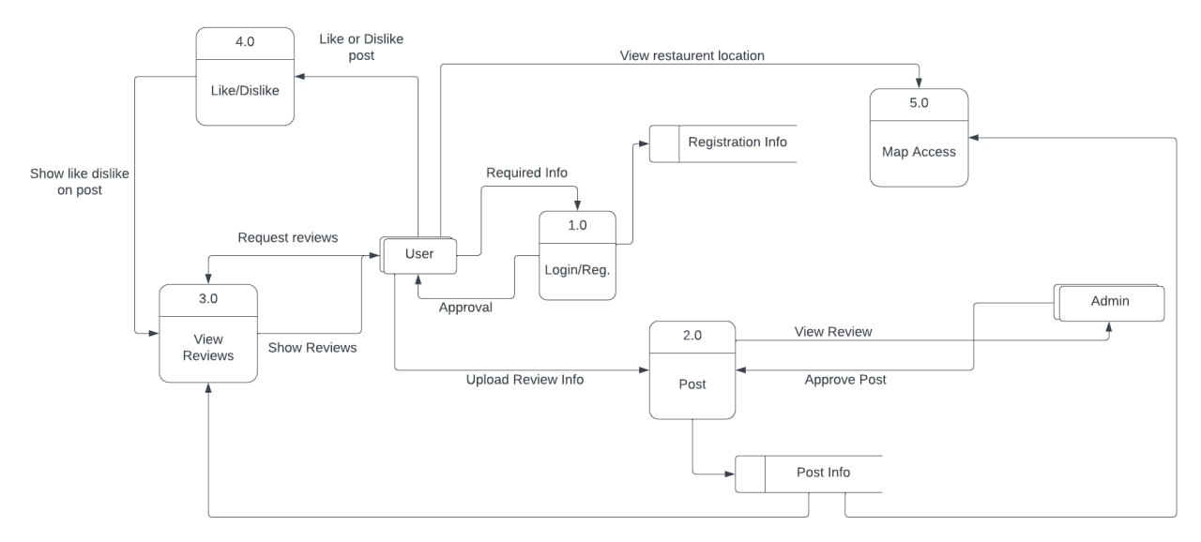

**2.4.3 Er Diagram:**

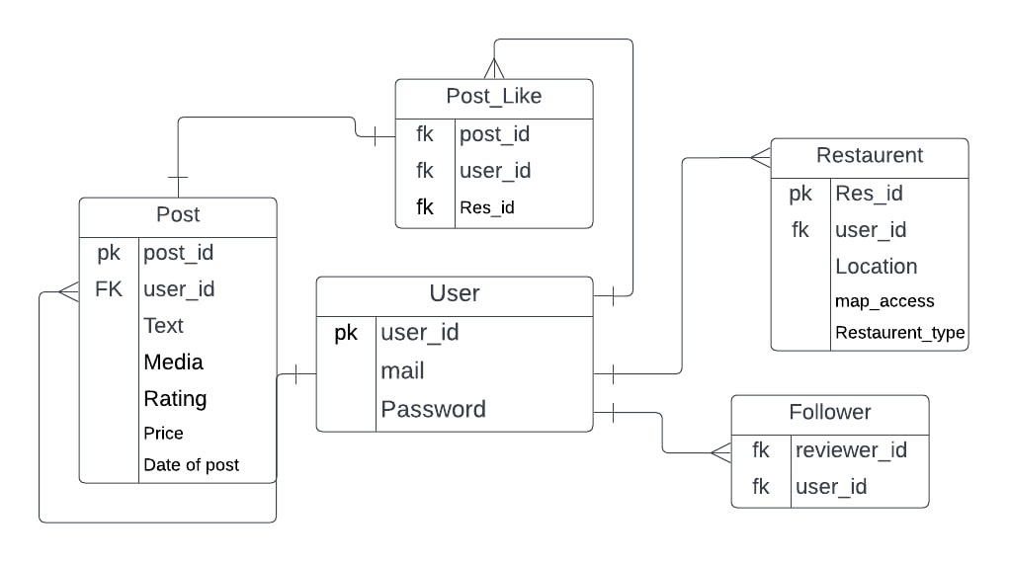

**2.4.4 Flow Chart**

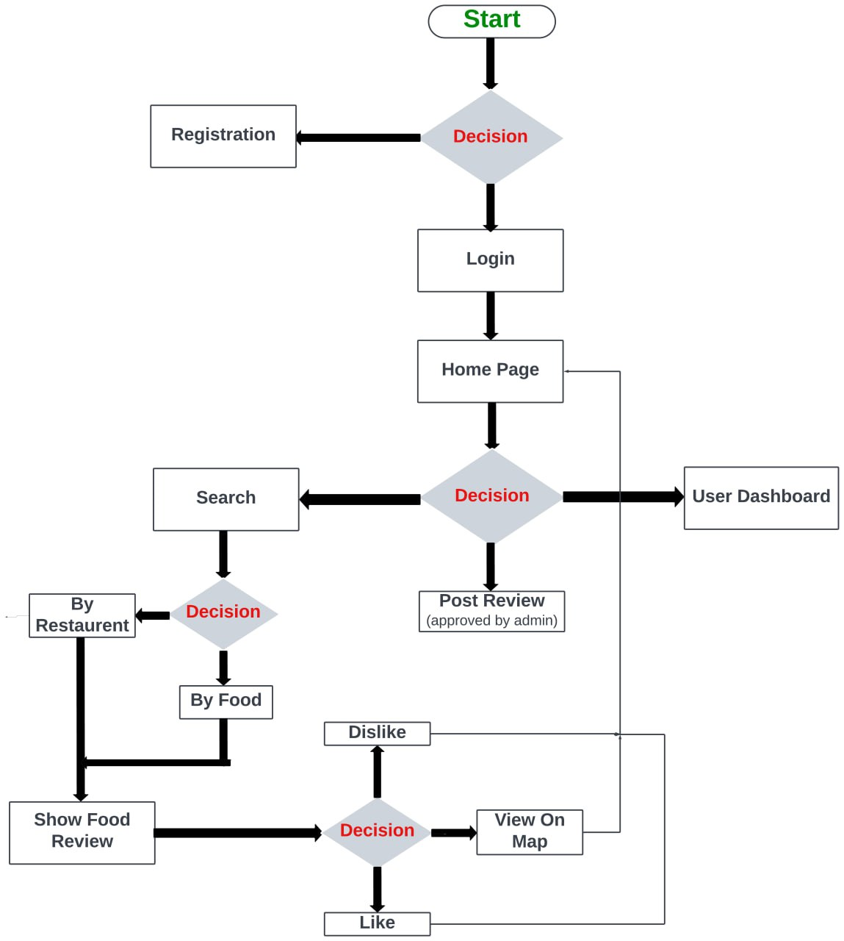

**2.4.5 Use Case Diagram**

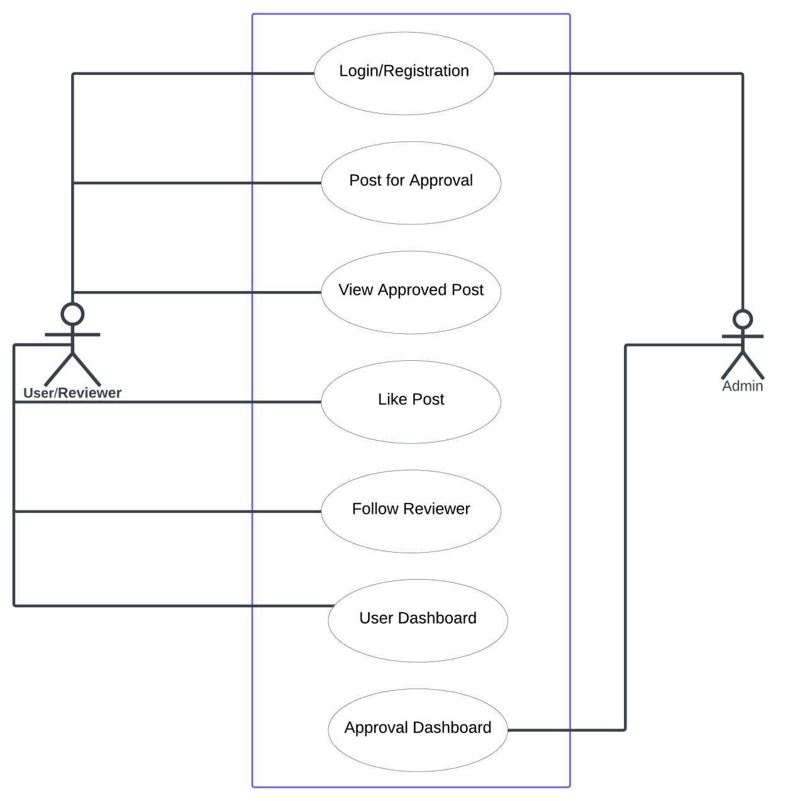

**2.4.6 Class Diagram**

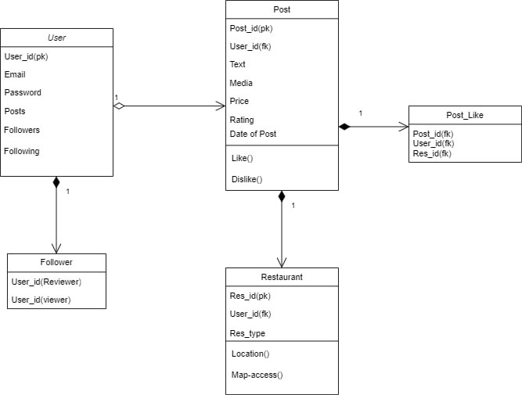

**2.5 Implementation**

**2.6 Conclusion**

In conclusion, "The Foodie System" is poised to disrupt the traditional restaurant discovery process by offering a comprehensive and interactive platform for food enthusiasts. With its user-friendly interface, robust features, and personalized recommendations, the app is set to become the go-to destination for culinary exploration. By connecting people through their shared love of food, "The Foodie System" will not only simplify dining decisions but also foster a sense of community among its users.

**CHAPTER 3**

**EXPERIMENTAL RESULT**

**3.1 Introduction**

We wanted the program to run so that the user can see what is the reviews. After the task has been completed, we went on testing the system through random person as user and obviously the admin. Through random user we checked if the login registration is working perfect with our database system. The admin will check if the approval management method was working or not.

**3.2 Result analysis**

After user test:

User: Everything is working well, as the interface is very easy to make review and see the food list.

Admin: Interface everything looks good, Dash doesn’t look well enough an improvement has been suggested.

**3.3 Conclusions**

In conclusion, the experimental results of the apparel foodie system suggest that technology solutions are essential. By investing in the right software and systems, people can make a significant platform on food basis.

**CHAPTER 4**

**USER MANUAL**

**4.1 Introduction**

In this chapter, how the system will work on website will be shown. We have designed the graphical interface by thinking of foodie’s choices. The website created according to our team members preferences. The website includes some webpages like Home, login, reviewer, foodie etc. The user needs to go through the Register/Log interface before the use of this website.

**4.2 System Requirements**

**4.2.1 Software Requirements**

* + - Operating System: Windows 7/ XP/8/10
    - Front-End: HTML, CSS, Java Script.
    - Front-End Framework: Bootstrap 5
    - Server-Side Script: PHP
    - Database: MySQL
    - Local server setup package: XAMPP, MySQL servers (If local server using)
    - Browsers: Firefox, Opera Mini, Chrome, Edge (All the browsers)

**4.3 User Interface**

**4.3.1 Sign-up / login:**

A new user must need to fill the registration form before visiting the website, whereas the old user will login with their email and password. The information from the register form will be submitted in database.

**Sign-up:**

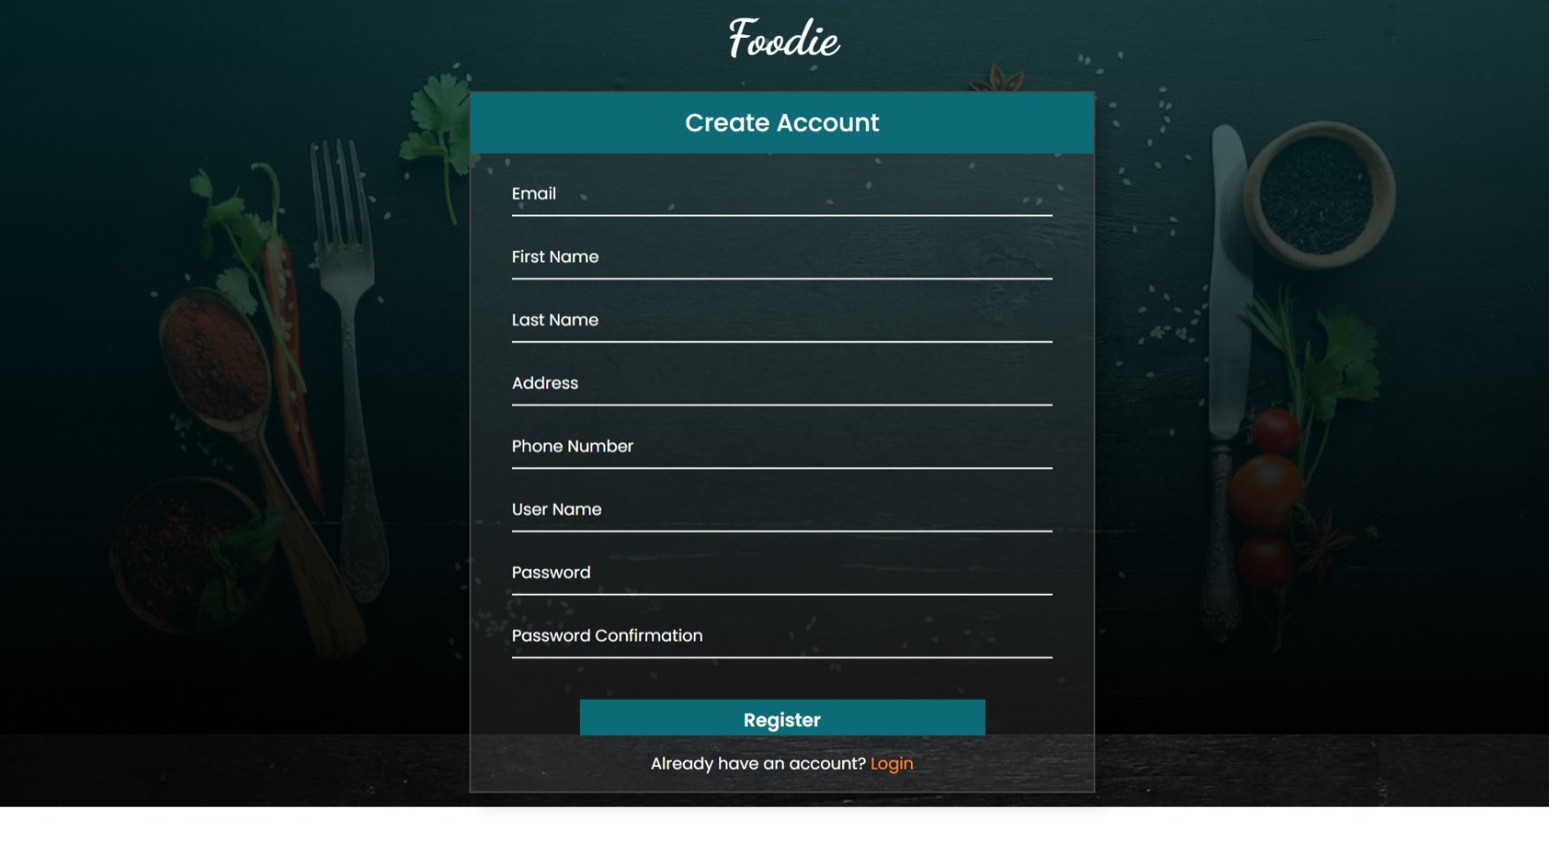

**Login:**

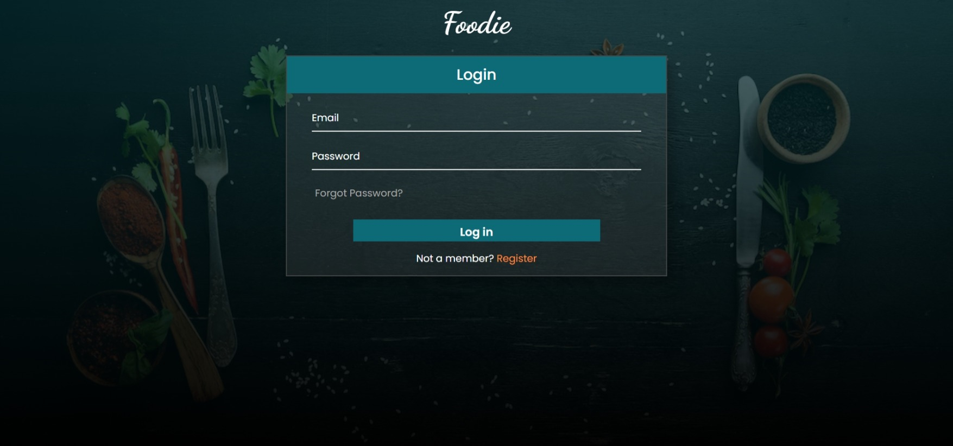

**4.3.2 Home page:**

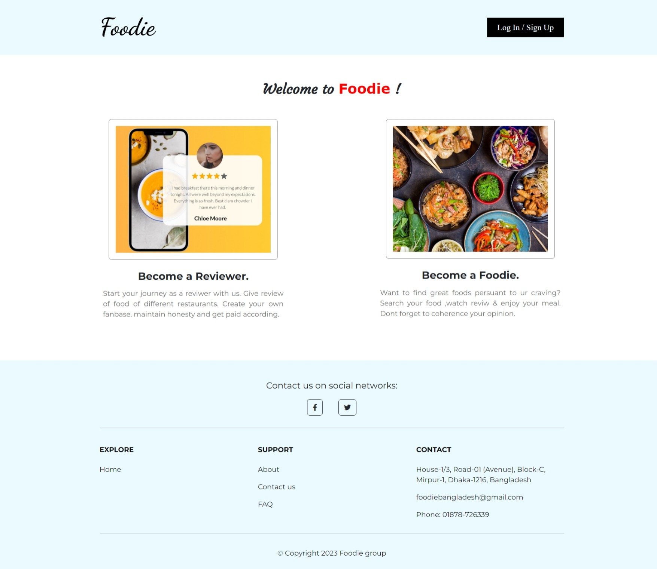

**4.3.3 Review page**

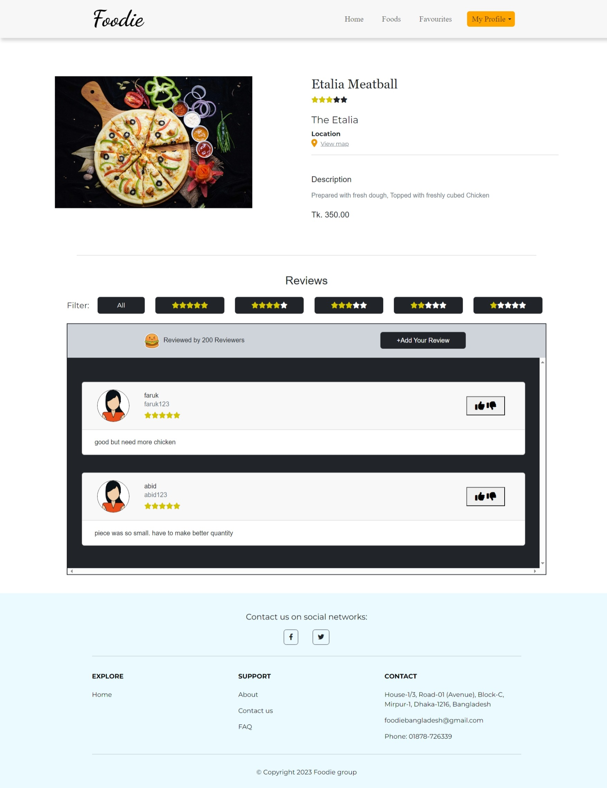

**4.3.4 Foodie page**

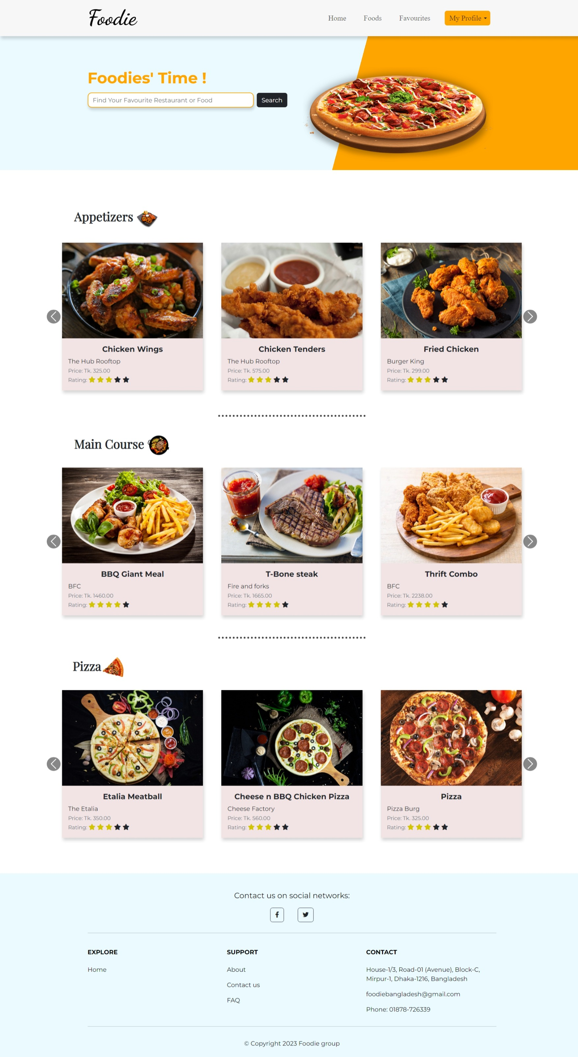

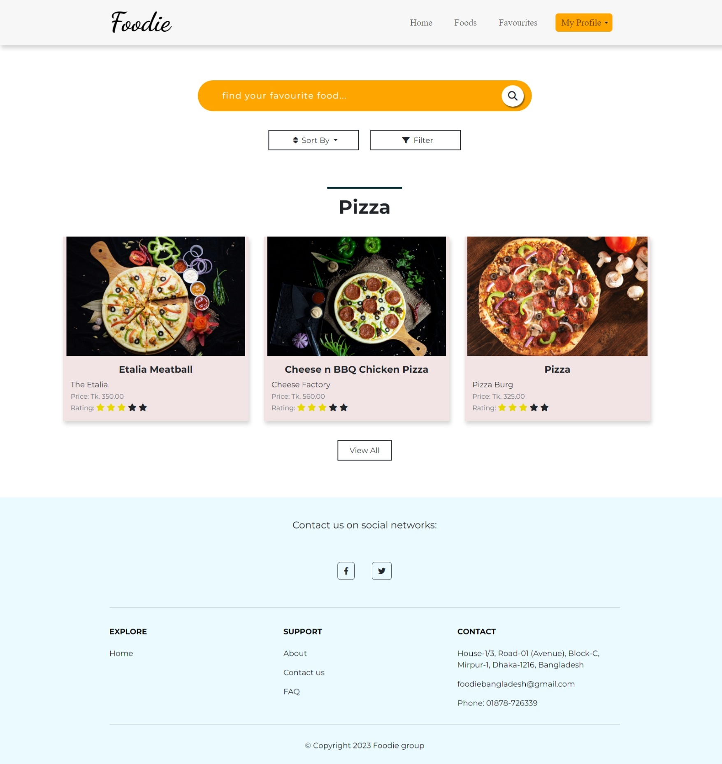

**4.3.5 Account (User) information:**

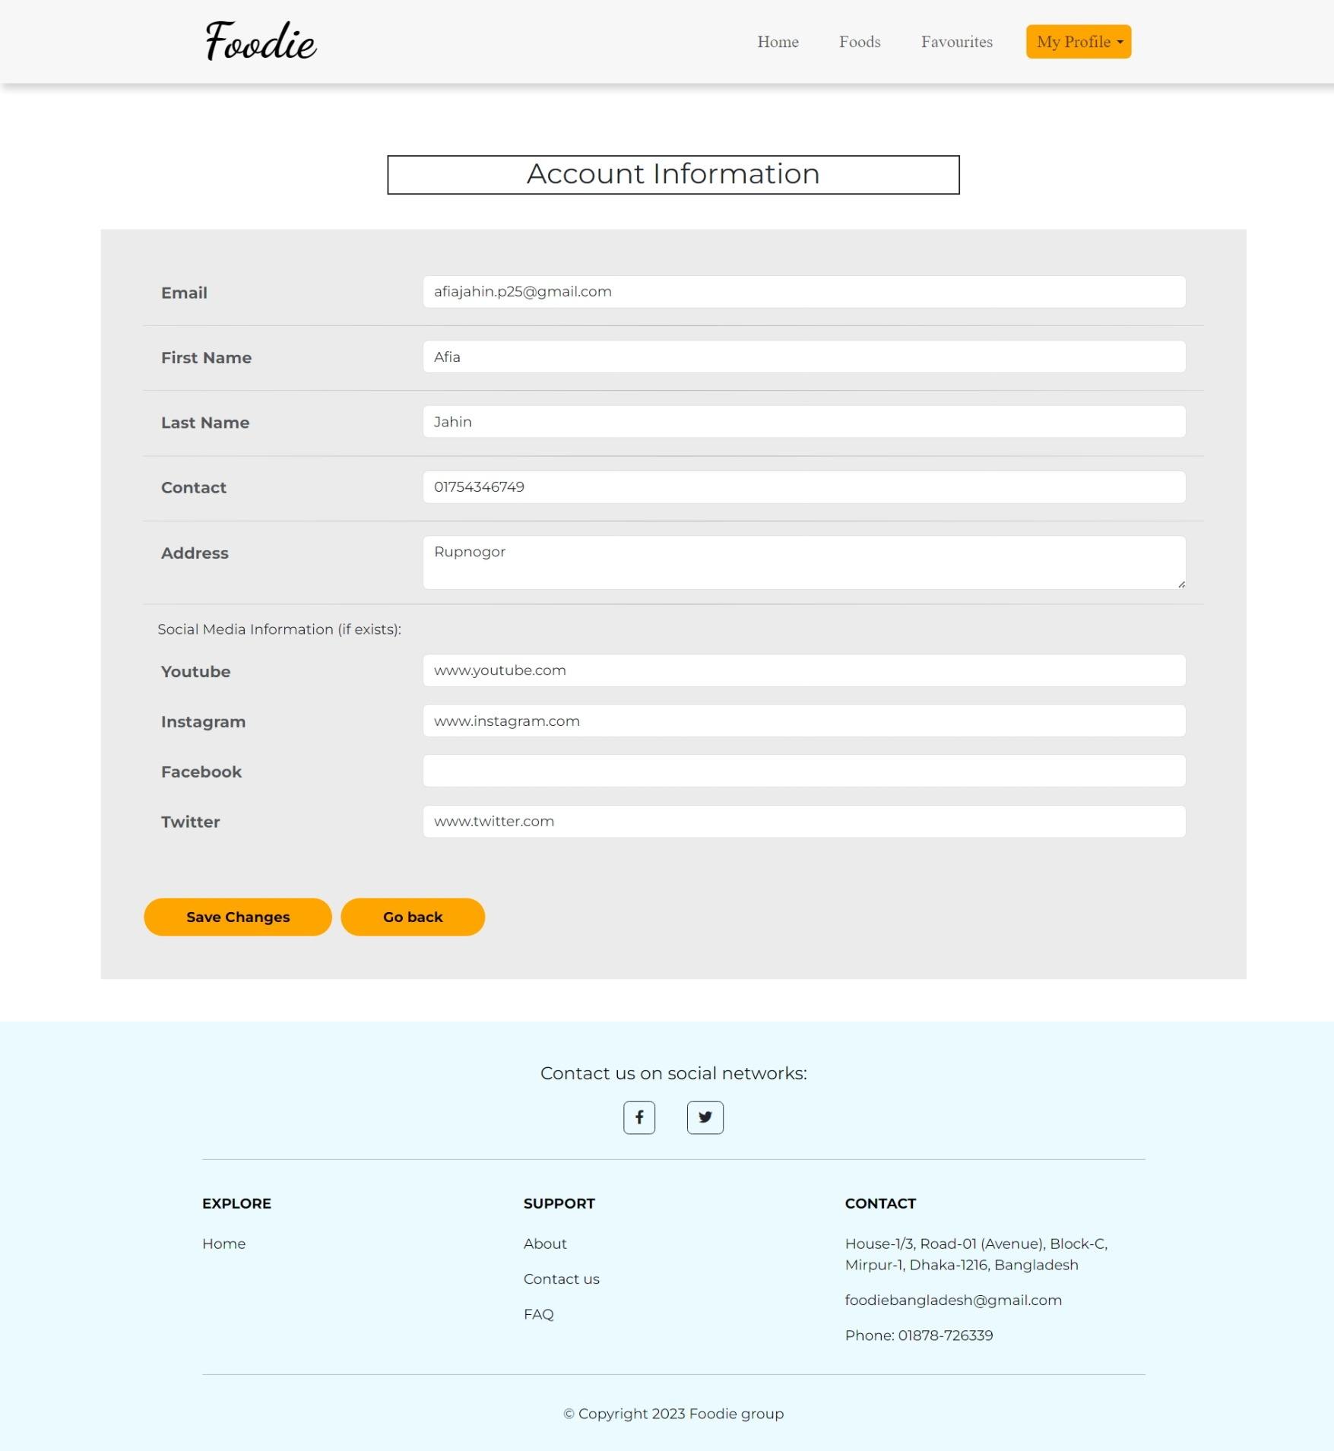

**CHAPTER 5**

**CONCLUSION & FUTURE WORKS**

**5.1 Conclusions**

In conclusion, "The Foodie System" is poised to disrupt the traditional restaurant discovery process by offering a comprehensive and interactive platform for food enthusiasts. With its user-friendly interface, robust features, and personalized recommendations, the app is set to become the go-to destination for culinary exploration. By connecting people through their shared love of food, "The Foodie System" will not only simplify dining decisions but also foster a sense of community among its users.

**5.2 Future work**

* Rating Restaurant: We want to update this system in future. Their will be an option of rating restaurant on their best sold food. Their will a list of restaurants on their area which serve healthy food and also basis of their decoration which is well design as young people provide and like to hangout.
* Delivery System: We also want to add delivery system in future. So that people can see the review and can order from home. The main motive that people can get best food by sitting home without visiting restaurant. This is for that kind of people who do not like to go restaurant but they are foodie.